March 23, 2023 – Java Project – Thea Gregory 5291240

Today I worked on the following:

* Created the restaurant table in the mysql database
* Completed the restaurant model and controller
* Created the save query that will update the database

I am happy with my progress. The restaurant is the biggest part, and it’s coming together nicely as I will show in my screenshots. I have not yet tested the save function or the validations as of this writing, that will be a task for this afternoon. The database is clean and efficient. All that remains is to create functions that will add the manager and restauranteur to the users table, which is a trivial task. My biggest challenge today was formatting the JTextArea for the delivery areas. I expect some testing and debugging will be necessary on that side.

Screenshots:

A sample of the restaurant table structure from the database:

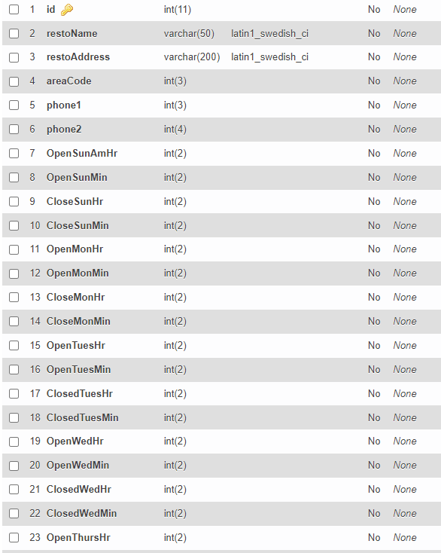

A function to simplify validation checks:

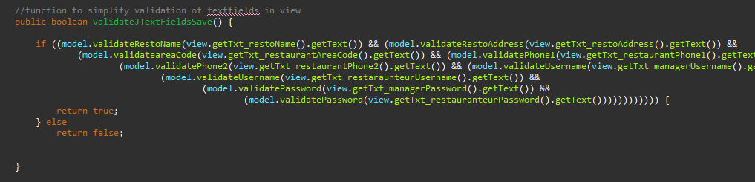

Adding to Delivery Area TextArea display:

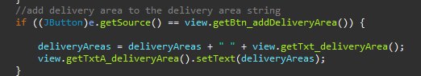

Deleting from Delivery Area display:

